Railman App

The Food Catering Service

For

Indian Railways and Beyond

**Assignment 1 Group 9**

**Avijit Nandi Shiva Krishna K Sachin Gaurav Srivastava**

-

**TABLE OF CONTENTS**

**SECTION 1 – The Feasibility Study**

* **The Business Case**
* Mission Statement
* Goals
* Industry Analysis
  + The Indian Railway Online Catering Industry
  + Other Rail Catering Apps
  + The Online Food Services Industry
* Issues/Risk with current Online Food Services solutions
* **The Requirements**
* Functional Requirements
* The Actors and Use Cases
* Non-functional Requirements

**SECTION 2 – System Design**

* **Logical Architecture**
* UI Layer
* Application Layer
* Domain Layer
* Technical Services
* Foundation Layer
* **Static Model**
* **Sequence Diagram**
* **ER Diagram**

**SECTION 1 – The Feasibility Study**

**Goal/The Market and Industry Trends/Challenges/The Services**

* **The Business Case**

Recently Indian Rails have decided to open up the train booking related information through APIs to the application developers so that useful applications can be developed around those APIs.Railman App is an upcoming startup that plans to leverage this opportunity to release new food catering services to the Indian rail passengers.

* **Mission Statement**

To use NexGen technology enabled Hybrid application to enable informed food choices for railway passengers at various railway zones and stations. Railman App aims to close the gap between cultures and geographies - through food choices, availability of favorite menus and maintaining freshness and quality of food.

* **Goals**

Railman App’s immediate goals involved the following.

* Offering wholesome, fairly priced, ethnically diverse food options
* Creating an attractive and diverse menu
* Providing excellent customer services that enhances the rapport with rail passengers
* Increase speed of service, sales volume and customer satisfaction
* Develop high accuracy product (>90% accuracy) and stable platform (99% stable)
* Explore and integrate with platforms under Travel and Tourism, Food delivery, Health and Fitness.
* **Industry Analysis:**
* **The Indian Railway Online Catering Industry**

Today IRCTC which was established on 27 September 1999 is the only entity that is authorized to provide certain services to the Indian Railways, including online ticketing, catering, and selling drinking water on trains and at railway stations.

IRCTC introduced pantry cars inside long or medium distance trains which catered to passengers by serving freshly cooked food. IRCTC has exclusive rights for onboard catering of food on all trains operated by the Indian Railways. It also operates food plazas, Jan Aahar cafeterias and refreshment rooms at various railway stations.

In 2014, IRCTC launched e-catering services which allowed passengers to order an array of food of their choice from reputed brands as well as popular regional and local delicacies on phone or online while traveling on trains and get the same delivered to their seats at railway stations. Initially, the service was introduced in around thirty railway stations catering to approximately 250 trains. Passengers can download IRCTC E-catering App “Food On Track” from the various App stores and avail E-Catering Services. They can also book the food from the website <https://www.ecatering.irctc.co.in>.

**Some of the online Food Catering Partners registered with IRCTC**

Today IRCTC E-catering service provides meals from over one thousand restaurants, has delivered over one crore meals and its application “Food on Track” has been installed over 50 Lakh times. For Railman App to provide the catering service to Indian railway passengers ,it would require a license from IRCTC by registering as a Vendor partner.

* **Other Rail Catering Apps:**

[**RailRestro**](https://www.railrestro.com/)**:** RailRestro is one of the highest rated rail food catering apps available in playstore. This app provides a wide range of features such as multi cuisine food menu, group ordering, order tracking, locations, special Jain food apart from RailTools such as PNR status, train schedule and others. The app has both mobile and web-app versions available (with almost all features available in both platforms). Web-app additionally has “Restaurant Owner Signup and Partners” feature for partner Restaurants to sign-in.

[**ZoopIndia**](https://www.zoopindia.com/order-food-delivery-in-train?gclid=Cj0KCQiAveebBhD_ARIsAFaAvrE8kDC8IQ-wC9KgQPsMNb0L58BYSAy29AdOuoL1Cf1eKdDQkpK7IIoaAlwdEALw_wcB)**:** ZoopIndia is another leading Rail Catering app that has a plethora of features ranging from multi cuisine food menu, bulk order, special Jain food. This app allows users to pre-book food in all Railway Zones. It provides order tracking facility similar to IRCTC E-catering app.

We also investigated other available Rail Catering Apps such as **TravelKhana, OLF and Food on track**. A comparison of major features available in these apps is as follows. This analysis helped us to identify prominent features that we should support in our App to be competitive.

**Feature comparison between different Apps:**

| E-Catering | RailRestro | Zoop India | TravelKhana |
| --- | --- | --- | --- |
| Account services | Account services | Account services | Account services (only in Mobile App) |
| PNR/Train Search | PNR/Train Search | PNR/Train Search | PNR/Train Search. Limited trains |
| Restaurant Select | Restaurant Select | Restaurant Select. | Restaurant Select. |
| Food Select/Jain food | Food Select/Jain food | Food Select/Jain food | Food Select |
| Station Select | Station Select | Station Select | Station Select |
| View Cart | View Cart | View Cart | View Cart |
| Payment | Payment | Payment | Payment |
| - | - | - | Restaurant owner login |

* **The Online Food Services Industry**

Keeping the overall goal and expansion vision of Railman App it is important to look at the current industry of Online Food Catering in general.

Food delivery market in India is worth over 12.5 billion, online food delivery is contributing more than 7% to this market. More than 50,000 restaurants in India provide home delivery, indicating a very high potential and untapped market in the online food delivery space.

Players in the industry broadly classified into three categories:

* Fully integrated: Those who process food and deliver (Dominos, McD etc.)
* Delivery as a Service
* Aggregators: Provides a platform for customers where they could discover restaurants, navigate through menus of different cuisines and select the food. Delivery made by the restaurant. In short, it aggregates information about food for customers and functions as an order generating channel for restaurants. (TinyOwl, Zomato, Food Panda etc.).

Reasons for growth in online food delivery industry:

* Increase in disposable income and deeper internet penetration of customers (web/mobile).
* Restaurants tying up with online food delivery platforms claim to get a profit margin of more than 2 to 3% than dine-ins.
* **Issues/Risk with current Online Food Services solutions**

Food Online Ordering Startups are struggling to capture Market Slice and who will be next Market Leader is a big question in the market.

**The areas of services where Food Online Ordering Startups facing the Challenges and required area of improvements:**

**1) Miscommunication between Customer and Restaurant:**

This is the most common challenge all food tech online order startups face and causes an endless number of problems at both the ends of Supply and demand. They need to improve and train their Customer Public relations and Call center/Order booking divisions to avoid such miscommunications and confusions from both Demand and Supply Side.

**2) Food Delivery service:**

Avoid false Commitments to Customers for delivery within 30 minutes etc., be practical and realistic. Some Cases, delivery delay is more than 2 hours (exceptions but not all cases) . Improve your 3rd Party Delivery/Logistics Service or build a strong inhouse Supply Chain/ Logistics Team with clear insight of delivery terms and conditions, Food Safety and quality.

**3) APP service /Website Service:**

Sometimes Locality is not visible, not identified and many more reasons Customers could not be able to locate or trace the nearby or right restaurants. Improve your Data Analytics and Technical

Database support System to improve the Customer Service. Make App one stop solutions.

**4) Customers Private Information Stored by APP :**

Why is it required by APP to store all device id, device and app history, access of SD card, and customer Contacts. It is something against customer Privacy. Customers do not like to share their private information.

**5) Limited Payment Options / Refund Policies:**

Give more options to Customers for Payments like Debit/Credit Card, Net Banking, Mobile Wallets, Payment Banking, Coupon encashment and many more. Improvement required in refund

policies, and to train the staff to resolve the Customer disputes for food quality/services etc. Here Best Customer Service and Public Relations and Public Grievances dept to co-ordinate and try to

minimize all such refund cases and resolve the issues in the best possible way.

**6) Limited Restaurants registered and Easy to use Interface:**

Give more options to your customer with easy to access and user-friendly screen (apply UX/UI best user experience) so, Customers can easily scan everything on one go. All Restaurants are not

registered so FIX it first.

**7) Food Tips:**

Include Tips for Menu, Food Ingredients, and Food Appetite. Incorporate Preview Image for every dish with ingredients details.

**8) Customer Comments options while ordering:**

Give options to customers to add extra comments for food like Jain food, allergies, spicy, Include/ Exclude of Ingredients etc.

**9) Discount Offer:**

Offer Occasional deals to customers like event based and make it effortless and convenient food ordering experience to all users.

**10) Order Tracking Status:**

Develop the best Online experience to all users through showing Status of Food, from Kitchen, Delivery person to Customer. Make it more Live and customer friendly.

**11) Quality Of Restaurants:**

Let us Food Ordering Startup's Representative frequently Visit or go for surprise checks of a few restaurants’ kitchen and to check quality control of food preparation area, hygiene and food quality.

TinyOwl is the dark horse but standing at position fourth in this stiff competition market Zomato is currently the market leader, but Swiggy has come over most of the problems that people expected

in the market and giving a strong challenge to the position of FoodPanda.

As per research done on understanding service gaps and competitive analysis of online food ordering apps a set of questionnaires was used to collect responses of current online food ordering users. Questionnaire consisted of closed ended questions focused on understanding consumers convenience, preferences, and expectations.

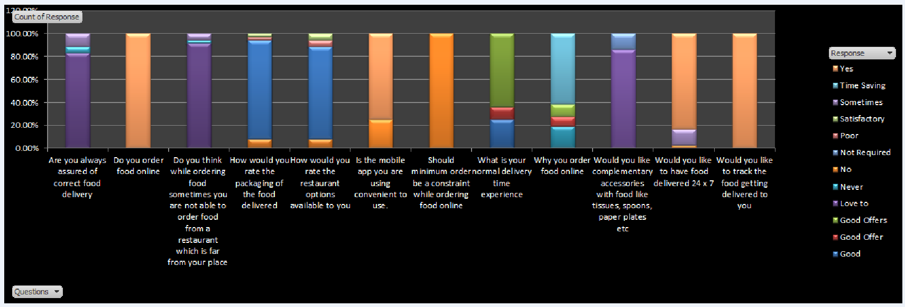

The above graph displays a consolidated view of the responses collected from the questionnaire from various respondents. In a way it highlights the expectation of the people and to which level it has been met or satisfied by the online food industry giants. It also answers questions regarding where this industry has reached and which direction it is going. It describes the scope for improvement as well.

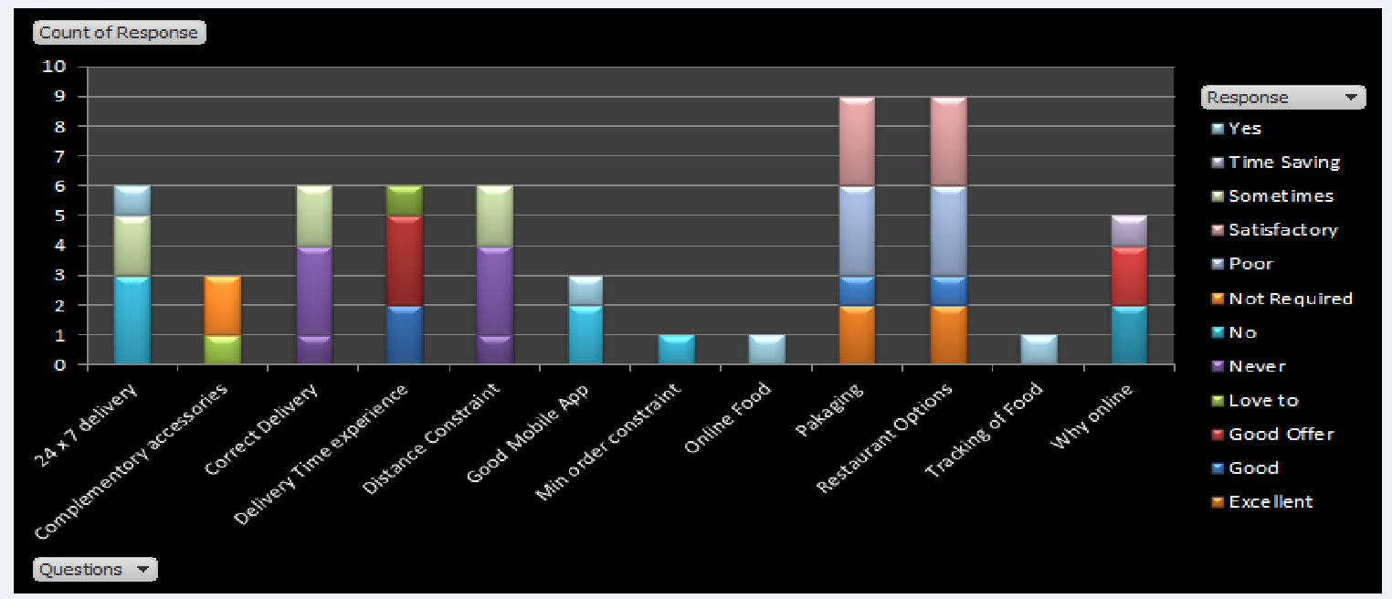

Most of the people (~80%) do get the correct delivery of food that they had ordered. However, there is a good percentage of people who have a feeling of discontent regarding it.This highlights the gap in communication between the online food industry and the registered restaurants that needs to be looked into. Swiggy has produced an initiative in which they do verify the order delivered versus the order placed, this would somewhere definitely eliminate human error.

Not being able to order food from Far away located restaurants is a very genuine problem that people do face while ordering food online. And a huge number of people agree on having this issue. The food online industry has a small radius in an area of restaurants from where they can order food online. Many times, a user is not able to order food just a little distance from his house because it does not fit into the radius of delivery. This problem needs to be tackled. Swiggy has a better radius of delivery compared to Food Panda and Tiny Owl.

Most people are satisfied with the packaging of their order, but it will be good to reach the excellent mark with more users because packaging adds to the physical evidence of a service and never fails to impress or leave a bad mark.

People are satisfied to a good extent by the restaurant options available to them, but the food online industry should focus on increasing its web around the city to cover as many restaurants as possible.

Twenty-five percent of people feel that their mobile app is not very easy to use. This is the technological aspect and the only channel where the customer interacts with the food online industry. So, it will be advisable to the companies to focus more on it and make it even more user-friendly.

Minimum food order has always been a problem when it comes to ordering online and people are not really happy with it. Swiggy has removed this constraint from their model and getting a good response from the market

Nobody likes to wait, especially when it comes to food. The delivery time experienced by most of the users is on a higher side. Food industry should be focused on quicker deliveries to the customer. Swiggy has produced a new delivery model which ensures delivery in 15-20 minutes

People have their own reasons for ordering food online, but the time saving option tops the chart, hence again it is important for the food to be delivered quickly.

* **The Requirements**

At a high level, the structure of the online food catering application system can be divided into three main logical components. The first component must provide some form of menu management, allowing the restaurant to control what can be ordered by customers. The second component is the web/app ordering system and provides the functionality for customers to place their order and supply all necessary details. The third and final logical component is the order retrieval system. Used by the restaurant to keep track of all orders which have been placed, this component takes care of retrieving and displaying order information, as well as updating orders which have already been processed.

As can be seen in the system model diagrammed above, each of the three system components essentially provides a layer of isolation between the end user and the database. The motivation behind this isolation is twofold. Firstly, allowing the end user to interact with the system through a rich interface provides a much more enjoyable user experience, particularly for the non-technical users which will account for the majority of the system’s users. In addition, this isolation layer also protects the integrity of the database by preventing users from taking any action outside those which the system is designed to handle. Because of this design pattern, it is essential to enumerate exactly which functions a user will be presented, and these functional and NFR’s are outlined below:

* **Functional Requirements**

1. Users should be able to search for a restaurant by its name.
2. Users should be able to search food by the food category/cuisine.
3. The user should be able to see the online menu given a restaurant. Menu will have different sections and each section will have a menu item.
4. The users should be able to see a list of restaurants given a cuisine type.
5. The users should be able to add meal items in their order cart. Multiple meal items can be added. Users can update their order cart before placing the order.
6. Users can select a time when they want their order to get delivered.
7. User should be able to Receive confirmation in the form of an order number and have regular tracking notifications
8. The system should be able to generate the order.
9. The system should be able to allocate a delivery order to a delivery agent.
10. The system should not allow the users to add items from different restaurants at the same time.
11. System should support multiple payment options like credit cards, paypal etc.
12. The system should maintain an order log for each customer for future reference.
13. System should be able to send notifications regarding the order status.
14. System should display a message in case of a closed restaurant.
15. Any guest can search for the restaurant and menu items, however, in-order to place a delivery order, the guest should become a member.
16. The system should forward the placed order to the specified restaurant.
17. Users should be able to add additional instructions while placing an order.
18. Restaurant employees can add a new/update/delete food category/item to/from the menu.
19. Restaurant employees can update the price for a given food item.

* **The Actors and Use Cases**

The primary Actors of online food catering application solutions are given as follows .

| **Actor** | **Goal** |
| --- | --- |
| Customer | Search and Place Order,Cancel Order, Make Payment, Track Order, View Order History |
| Restaurants | Maintain Food Menu and Item Price and update availability, Check Orders, Change order status, Create Receipts ,Collect Payments |
| Admin | Manage Customers, Manage all the restaurants by adding, updating, and removing them from the list. Manage full application operations, Manage Order |
| Delivery Person | Manage Delivery, Driver can update his profile, through push notifications, drivers can get constant updates & alerts on Order |

**Use Case Diagram**

**Important Use cases**

We identified the following 5 use-cases that should be supported by the app.

| **Use Case Section** | **Description** |
| --- | --- |
| **Use Case Name : Search for Train/PNR** |  |
| **Scope** | Users should be able to search for a train for which they want to select a station to place food order. The search can be performed by Train number or User PNR number. |
| **Actor** | Customer |
| **Successful Completion** | Users search for a train using train ID + date or PNR number. |
| **Alternative** | None |
| **Precondition** | 1. Non-members can only view the food list offered while members need to login so that they can place an order for their selected services. 2. If the user searches by train, he should be able to select a date. 3. Train number + Date and PNR must be valid. |
| **Post Condition:** |  |

| **Use Case Section** | **Description** |
| --- | --- |
| **Use Case Name : Browse Station and Restaurant Information** | Browse Station and Restaurants available in the route of a train. |
| **Scope** | This feature enables users to see all stations in the journey route of the selected train. He should be able to browse available restaurants at stations on the route. |
| **Primary Actor** | Customer/User |
| **Alternative** |  |
| **Precondition** | To browse all stations the PNR or the train ID and date must be valid.  Some restaurants should be registered at the station selected. For example at Bangalore SBC station some restaurants may be available. At Mumbai central another set of restaurants are available. For some stations no restaurant/Food catering may be available. |
| **Post Condition:** |  |

| **Use Case Section** | **Description** |
| --- | --- |
| **Use Case Name : Place Order** | The customer places the order |
| **Scope** | This feature is used to place an order by the customer |
| **Actor** | Customer |
| **Successful Completion** | 1. Customer can view and select the items from the food menu from any restaurant 2. Customer can place an order post the selection of food items 3. Customer can make a payment for this placed order 4. Restaurant owner confirms the order processed by the customer. |
| **Alternative** | None |
| **Precondition** | 1. Non-members can only view the food list offered while members need to login so that they can place an order for their selected services. |
| **Post Condition:** | Updated Order ID and Order Tracking |

| **Use Case Section** | **Description** |
| --- | --- |
| **Use Case Name : Browse Food Menu of a selected restaurant** | Search, add, update and remove Food Item information. |
| **Scope** | This feature is used to view and manage the list of foods reflected in the system. |
| **Primary Actor** | Restaurant |
| **Successful Completion** | Restaurants can search, add, update and remove Food List information. |
| **Alternative** | None |
| **Precondition** | Restaurants will need to login first to access the Food List management module. |
| **Post Condition:** | Updated food item. |

| **Use Case Section** | **Description** |
| --- | --- |
| **Use Case Name : Process Order and track delivery** | Take action on the order |
| **Scope** | This feature is used to process orders in the restaurant. |
| **Actor** | Customer and Restaurant and Admin |
| **Successful Completion** | 1. Customer can view and process order for the selected foods offered by the restaurant 2. Restaurant owner can confirm the order processed by the customer. 3. Admin can search, add, update, and manage the foods for order offered by the restaurant. |
| **Alternative** | Customers can only view the foods and process orders, while the admin or restaurant owner will confirm and process the order. |
| **Precondition** | 1. Non-members can only view the food list offered while members need to login so that they can process orders for their selected services. 2. Admin and Restaurant owner will need to login to add, update and manage the list of foods offered by the restaurant. |
| **Post Condition:** | Updated list of foods |

* **Non-functional Requirements**
* No. of orders = 10,000 orders per minute
* No. of cities and towns operational = 500
* Total number of restaurants listed on the application = 140,000
* Total active delivery partners = 2,00000
* Total number of order cancellations = 1,500 daily
* System should be highly scalable and available.
* Users should be able to get all features with minimal latency.
* **Scalability Estimation**

**Traffic Estimates**  
System is expecting 10,000 orders per minute. So, order requests per second will be10, 000 orders per minute/60 = ~ 167 Orders /Second

**Storage Estimates**  
Since we are expecting 10,000 orders per minute so, per day will be: Orders per day = 10, 000 orders/minute * 60 * 24 = 14,400,000 orders/day.

Total expected orders in 5 years = 14,400,000 orders/day * 12 Months * 5 Years = 864,000,000

Let us assume the size of object = 500 bytes, Total storage in 5 years = 432 GB

**Bandwidth Estimates**  
For order, since we are expecting 167 Orders /Second so, the total incoming data for the service will be:167 Orders/Second * 500 bytes = ~ 1 MB/Second

**SECTION 2 – System Design**

* **Logical Architecture**

The logical architecture of the system consists of 5 layers:

* **UI Layer:** The app will have 3 UIs for User, Restaurant/Partner and Admin. Users can invoke backend features such as PNR/Train Search, menu browsing, food selection, order payment, and delivery tracking through this UI. Restaurant/Partners can login to the system to update menu, add new restaurant through the UI. Admin UI is for administrative actions and maintenance.
* **Application layer**: Application layer consists of the Web Server and RestAPIs needed to cater to UI request and response. We plan to use Django and Python for implementation of the application and domain layer.
* **Domain layer:** This layer contains the business logic for various components. The major components are:
  + User management and authentication.
  + Menu and catalog search
  + PNR/Train search through IRCTC APIs
  + Ordering food
  + Add food to Cart to order later
  + Payment
  + Notification
* **Technical Services:** Technical services layer contains various services such as Database adaptors to connect with Database, create logger for logging activities.
* **Foundation layer:** Foundation layer has the persistence database. We plan to use relational database MySQL as the persistence database.

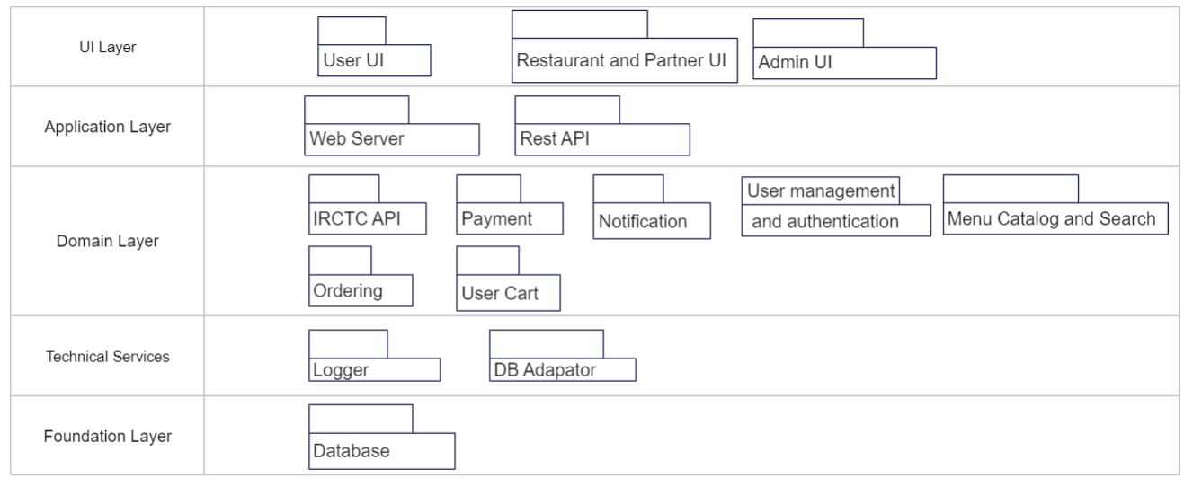

* **Static Model**

Based on the logical architecture described above we have identified the following classes. The main classes are User, Order, Journey, Station, Restaurant, Menu, Payment, Delivery, Delivery_agent, Notification and Cart. The UML diagram of the classes with main attributes are drawn below.

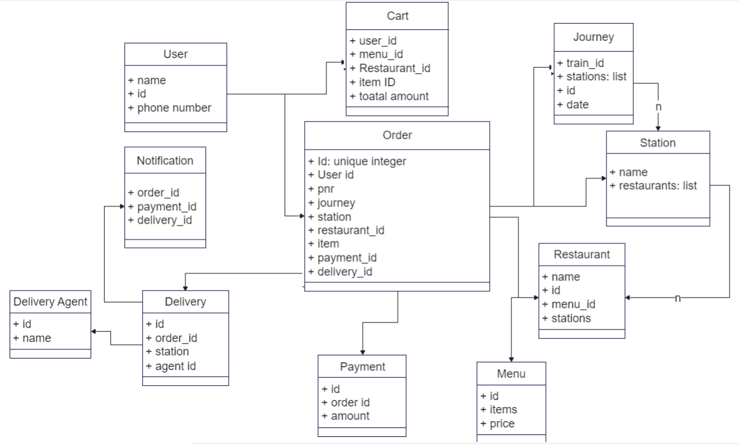

* **User Class**: Represents an user. The object of the User class is one of the main actors in the system. represented by Name and phone number. Users have a unique customerID. [Review later - is phone number sufficient?]. We can add any other details about users in this class.
* **Journey:** Journey represents a train_id and date. It contains a list of stations where the train halts during the journey. A journey object is created when a user searches for a PNR or Train ID using IRCTC API.
* **Station:** Represented by Station Name. [Review: Do we need an id?]. Contains a list of Restaurants available at that station.
* **Restaurant**: Has a Name and Restaurant ID. Contains a menu ID. Options list of Stations is also stored in this object.
* **Menu**: Contains items and corresponding prices.
* **Cart:** Represents last order selection for each user id
* **Order**: Main class to track an order. It has attributes user id, pnr, journey, station, restaurant_id, payment and delivery_id.
* **Delivery**: Has attributes order_id, station and delivery_agent.
* **Sequence Diagram**

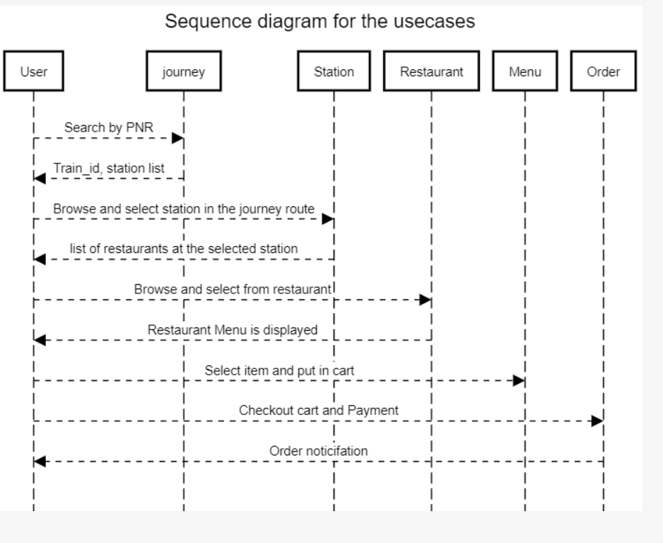

* **ER Diagram**

